Abercrombie & Fitch Co.  NYSE: ANF Equity Research • Consumer Discretionary / Apparel Retail | 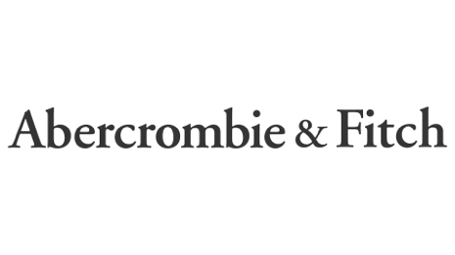
Report Date: 31 October 2025 Exchange: NYSE • Currency: USD
STRONG BUY | Current Price $70.90 | Target Price $109 (+53.74%) | Risk Medium | 12-mo. target

MARKET DATA  Market Cap $3.36 B  Revenue (FY24) $4,948 M  Revenue (LTM) $5,181 M  Net Income (FY24) $566 M  Net Income (LTM) $522 M  LTM EPS $10.74  P/E 6.6x  EV / EBITDA (LTM) 3.07x  EV / EBIT (LTM) 3.70x  Beta 1.35  All figures in USD; $ in millions unless noted. |  | SHARE PRICE — TRAILING 12 MONTHS  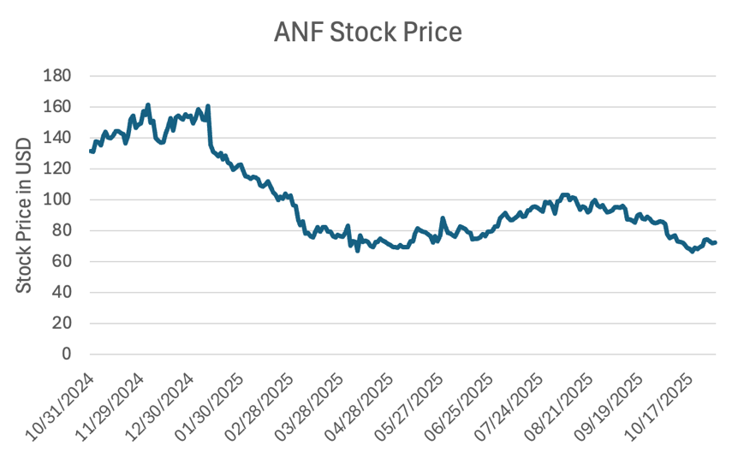
INVESTMENT SUMMARY
I believe Abercrombie & Fitch remains fundamentally strong with solid long-term growth potential despite its recent share-price decline. The sell-off looks overdone and largely driven by temporary concerns around the Abercrombie brand and a short-term deceleration. I remain confident in management's strategy, the brand portfolio, and the company's growth opportunities, which support the view that the stock is undervalued even under conservative growth assumptions. We rate the shares STRONG BUY with a 12-month target of $109.
Financial Statements
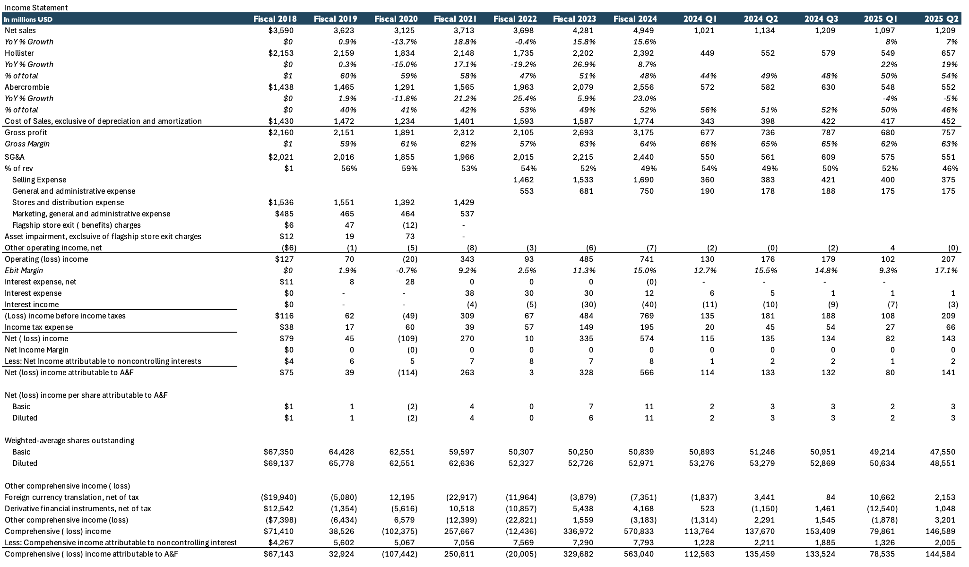
Figure 1 — Income Statement
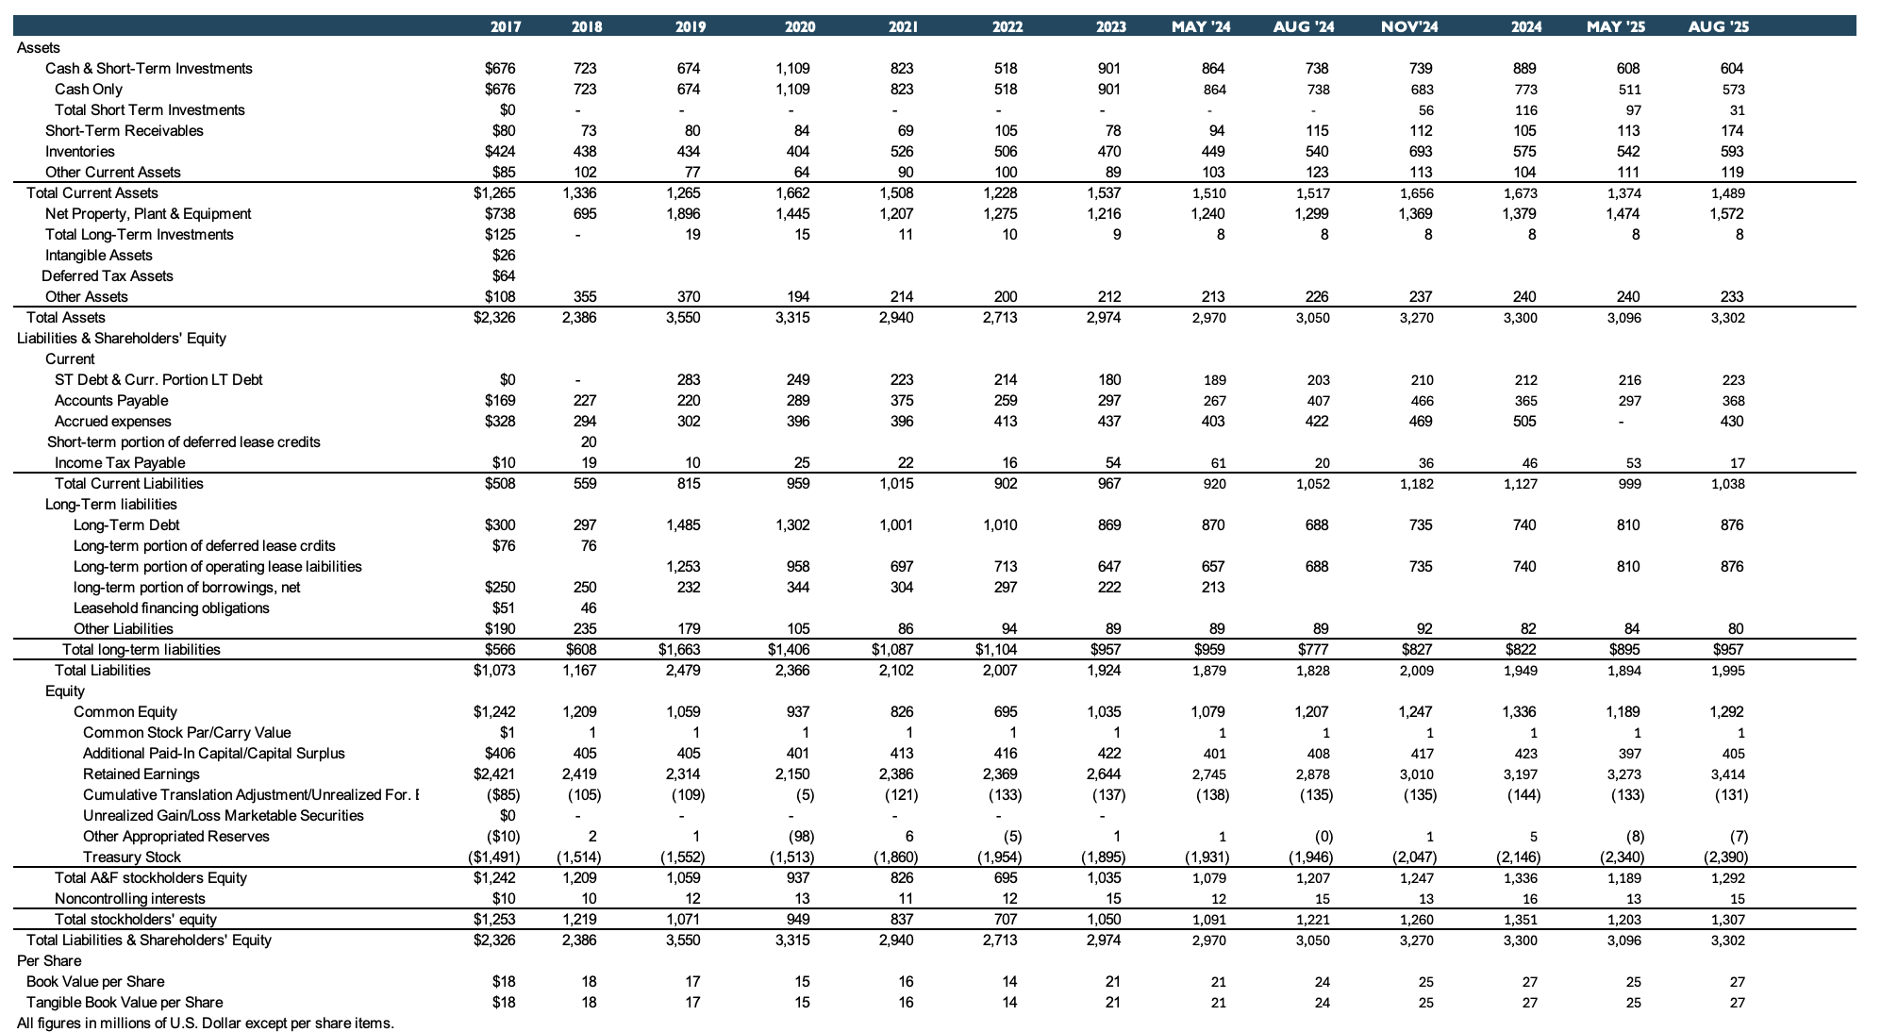
Figure 2 — Balance Sheet
Sales Analysis
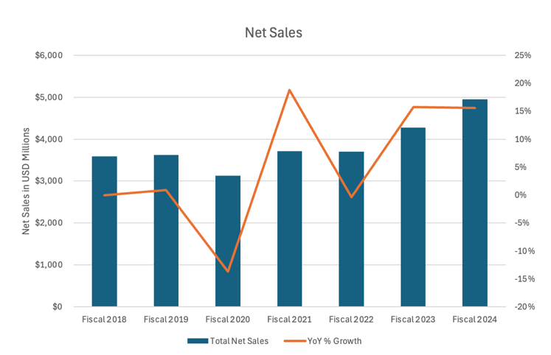  Figure 3 — Net Sales & YoY Growth | 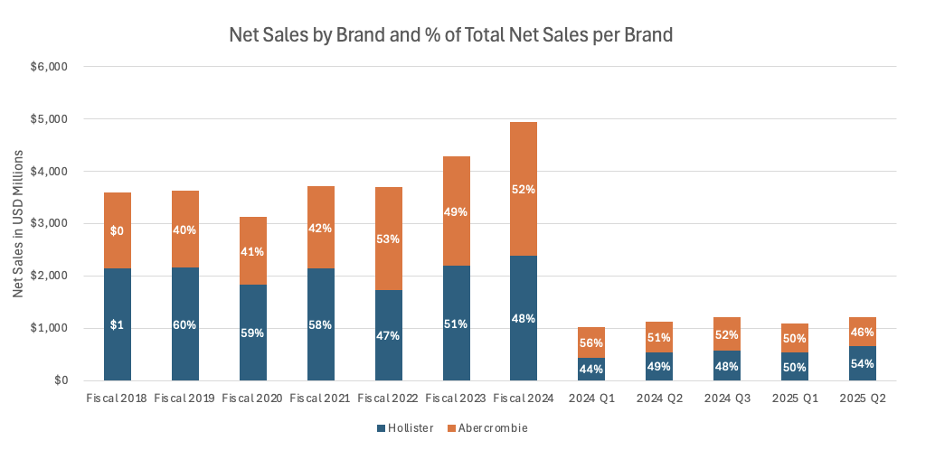  Figure 4 — Net Sales by Brand & % of Total

Since 2018, Abercrombie has delivered solid growth — a CAGR of 5.1% — taking a hit during COVID but recovering quickly the following year. Growth has been led by the Abercrombie brand (CAGR of 10.1%), while Hollister grew at 1.8% over the same period. In 2025 this trend shifted: Hollister became the biggest driver of growth, rising 22% and 19% in Q1 and Q2 respectively, while the Abercrombie brand declined 4% and 5%. Hollister's growth was driven mainly by existing stores, with comparable sales up 23% and 19%, whereas Abercrombie's comparable sales fell 10% and 11%.
Abercrombie's weak Q2 comparable sales were primarily driven by excess carryover inventory from the prior year, which forced increased promotions and markdowns. This lowered average unit retail (AUR) — which management identified as the main reason for the sales miss, not a lack of demand or traffic. In fact, traffic remained strong across both stores and digital channels.
Management explained that clearing higher-cost, excess inventory compressed both AUR and gross margin. Inventory at quarter-end was up 10% at cost and 7% in units year-over-year, indicating significantly more unsold merchandise than the prior year. As a result, even though units were selling and engagement was healthy, revenue per customer fell, pulling Abercrombie-brand comparable sales down 11%; selling through this inventory also pressured cost of sales.
Importantly, management emphasized that this was a temporary, self-inflicted issue, not a demand problem. By the end of Q2, inventory was described as “clean and current,” positioning the brand to reduce promotions and stabilize AUR going forward.
Margins & Profitability
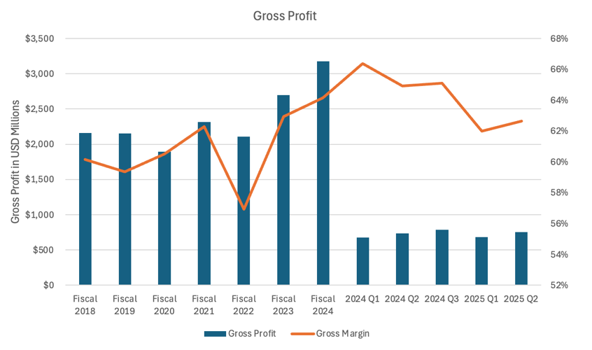  Figure 5 — Gross Profit & Gross Margin | 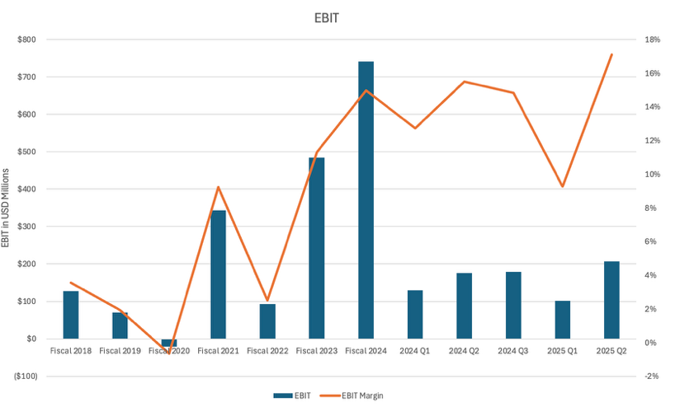  Figure 6 — EBIT & EBIT Margin

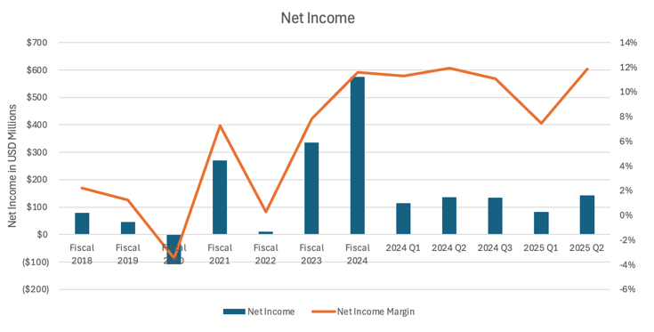
Figure 7 — Net Income & Net Income Margin
Over time, the company has demonstrated a clear improvement in profitability, with gross margins expanding structurally as pricing discipline, merchandising optimization, and supply-chain efficiencies improved following pandemic-related volatility. Gross margin recovered meaningfully after fiscal 2022 and has remained elevated, reflecting better inventory management and reduced promotional intensity.
Operating margins have followed a similar trajectory, with EBIT margins expanding steadily as SG&A leverage improved alongside revenue growth. While margins experienced short-term volatility on a quarterly basis due to seasonality and investment spending, the overall trend remains positive.
Net income margins have also strengthened over the long term, supported by higher operating profitability and improved cost control. Most recently, margins remain healthy — gross margin in the low-to-mid 60% range and EBIT margin in the mid-teens — indicating sustained pricing power and a structurally more profitable business than historically. The sharp margin decline in Q1 2025 is largely seasonal, driven by post-holiday demand normalization, higher promotional activity, and front-loaded investment spending.
Returns on Capital
Methodology
- ROTCE = EBIT / (NWC + NFA)
- NWC = current assets (excl. cash) − current liabilities (excl. short-term debt)
- ROIC = EBIT × (1 − tax rate) / [(assets − cash) − non-interest-bearing current liabilities]
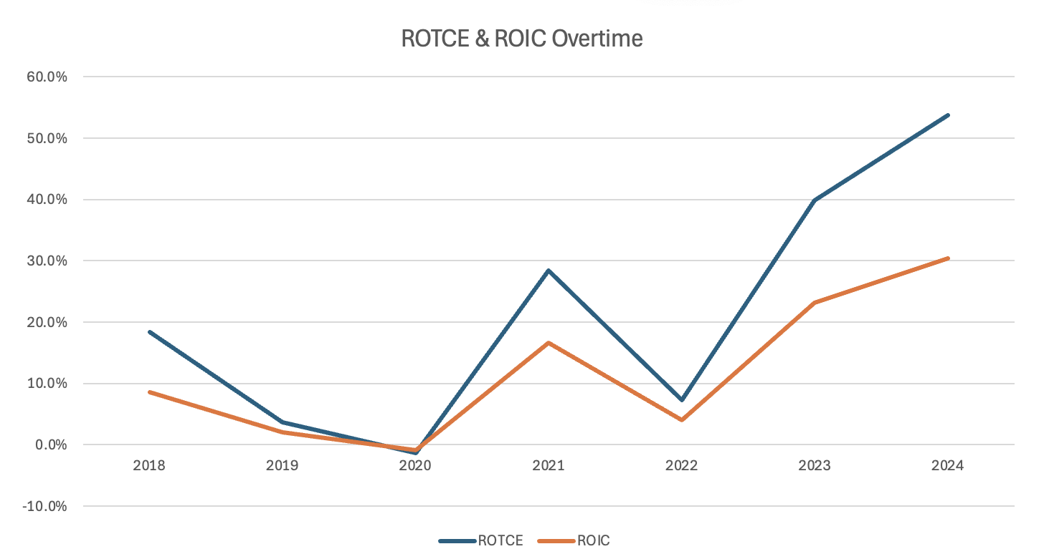
Figure 8 — ROTCE & ROIC Over Time
Abercrombie's returns on capital deteriorated significantly between 2019 and 2020, reflecting weak operating performance, store rationalization, and pandemic-related disruptions. During this period both ROTCE and ROIC reached trough levels as profitability declined and the capital base remained elevated.
From 2021 onward, returns rebounded sharply, driven by a meaningful recovery in EBIT, improved inventory discipline, and a structurally more efficient store footprint. The acceleration in 2023 and 2024 highlights strong operating leverage and improved capital allocation, as incremental investments generated significantly higher returns.
At current levels, both ROTCE and ROIC are well above historical averages, indicating that Abercrombie has successfully repositioned its business and is now generating returns meaningfully above its cost of capital.

